Web JDBC資料庫 Insert& Transaction
create table COFFEES
(COF_NAME varchar(32) NOT NULL,
SUP_ID int NOT NULL,
PRICE numeric(10,2) NOT NULL,
SALES integer NOT NULL,
TOTAL integer NOT NULL,
PRIMARY KEY (COF_NAME)
);
前置作業必須先完成: Web JDBC資料庫 Select文件內容
1. 修改index.jsp
<%@page contentType="text/html" pageEncoding="UTF-8"%>
<!DOCTYPE html>
<html>
<head>
<meta http-equiv="Content-Type" content="text/html; charset=UTF-8">
<title>JSP Page</title>
</head>
<body>
<h1>JDBC</h1>
<a href="/WebAppJDBC/SelectSupplier">讀取 Supplier 資料</a><br/>
<a href="/WebAppJDBC/UpdateCoffee.html">修改咖啡資料</a><br/>
<a href="/WebAppJDBC/InsertCoffee.html">新增咖啡資料</a><br/>
</body>
</html>
2.新增: InsertCoffee.html
<html>
<head>
<title></title>
<meta http-equiv="Content-Type" content="text/html; charset=UTF-8">
</head>
<body>
<form action="/WebAppJDBC/InsertCoffee" method="post">
咖啡名稱:<input type="text" name="coffee" value="Extra Espresso"/><br/>
售價:<input type="text" name="sale" value="200"/><br/>
總量:<input type="text" name="total" value="10"/><br/>
供應商:<input type="text" name="supplier" value="150"/><br/>
價格:<input type="text" name="price" value="300"/><br/>
<input type="submit" value="Send"/>
</form>
</body>
</html>
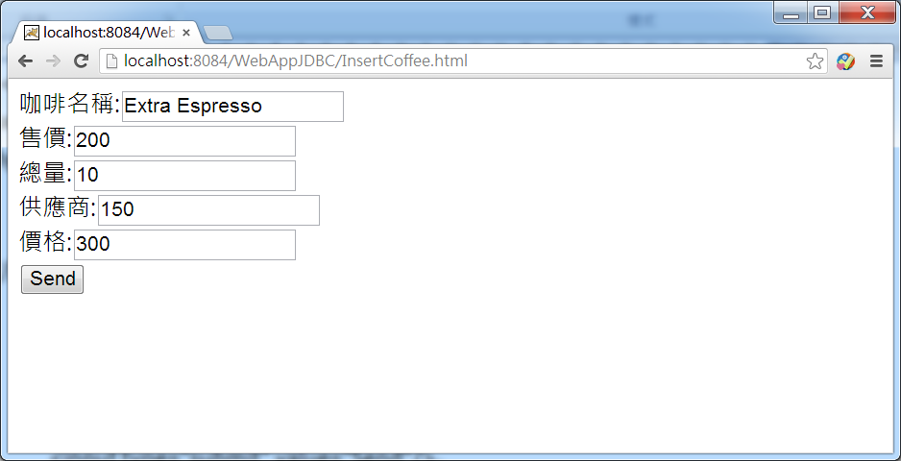
3.新增Servlet java程式InsertCoffee.java

import java.io.IOException;
import java.io.PrintWriter;
import java.sql.Connection;
import java.sql.DriverManager;
import java.sql.PreparedStatement;
import java.sql.SQLException;
import javax.servlet.ServletException;
import javax.servlet.annotation.WebServlet;
import javax.servlet.http.HttpServlet;
import javax.servlet.http.HttpServletRequest;
import javax.servlet.http.HttpServletResponse;

@WebServlet(urlPatterns = {"/InsertCoffee"})
public class InsertCoffee extends HttpServlet {

protected void processRequest(HttpServletRequest request, HttpServletResponse response)
throws ServletException, IOException {
response.setContentType("text/html;charset=UTF-8");
PrintWriter out = response.getWriter();
try {
/* TODO output your page here. You may use following sample code. */
out.println("<!DOCTYPE html>");
out.println("<html>");
out.println("<head>");
out.println("<title>Servlet InsertCoffee</title>");
out.println("</head>");
out.println("<body>");
String coffee=request.getParameter("coffee");
String sale=request.getParameter("sale");
String total=request.getParameter("total");
String supplier=request.getParameter("supplier");
String price=request.getParameter("price");
try {
InsertCoffee(coffee,sale,total,supplier,price);
} catch (SQLException ex) {
System.out.println(ex.getMessage());
}
out.println("新增完成");
out.println("</body>");
out.println("</html>");
} finally {
out.close();
}
}
public void InsertCoffee(String coffee,String sale,String total,String supplier,String price)
throws SQLException {
Connection con=null;
PreparedStatement insert= null;

String insertStatement =
"insert into COFFEES( COF_NAME , SUP_ID , PRICE , SALES ,TOTAL)" +
"values ( ? , ? ,? ,? ,?)";

try {
Class.forName("org.apache.derby.jdbc.ClientDriver");
con = DriverManager.getConnection("jdbc:derby://localhost:1527/JavaDBDemo","APP","APP");

con.setAutoCommit(false);
insert = con.prepareStatement(insertStatement);

//for (Map.Entry<String, Integer> e : salesForWeek.entrySet()) { }
insert.setString(1, coffee);
insert.setInt(2, Integer.parseInt(supplier));
insert.setDouble(3, Double.parseDouble(price));
insert.setInt(4, Integer.parseInt(sale));
insert.setInt(5, Integer.parseInt(total));
insert.executeUpdate();
con.commit();

} catch (Exception e ) {
System.out.println(e.getMessage());
if (con != null) {
try {
System.err.print("Transaction is being rolled back");
con.rollback();
} catch(SQLException ex) {
System.out.println(ex.getMessage());
}
}
} finally {
if (insert != null) {
insert.close();
}
if (insert != null) {
insert.close();
}
con.setAutoCommit(true);
}
}
@Override
protected void doGet(HttpServletRequest request, HttpServletResponse response)
throws ServletException, IOException {
processRequest(request, response);
}

@Override
protected void doPost(HttpServletRequest request, HttpServletResponse response)
throws ServletException, IOException {
processRequest(request, response);
}

@Override
public String getServletInfo() {
return "Short description";
}// </editor-fold>
}
PS>最後請同學加入程式讀取新增後的Coffee表格資料

